|  |  |
| --- | --- |
| Bug-ID | TU1-I6 |

|  |  |
| --- | --- |
| Brief Summary | User is unable to proceed with a payment |

|  |  |
| --- | --- |
| Severity | Show Stopper |

|  |  |
| --- | --- |
| Steps to Reproduce |  |

Steps for Reproducible bug:

1.Add an item in

shopping cart.

2.Enter all Mandatory fields.

3.Click Continue.

4.Click continue in Billing details.

5.Enter the details asked.

**Expected Result**

User should be able to proceed with a payment.

**Actual Result**

User is not able to do payment.

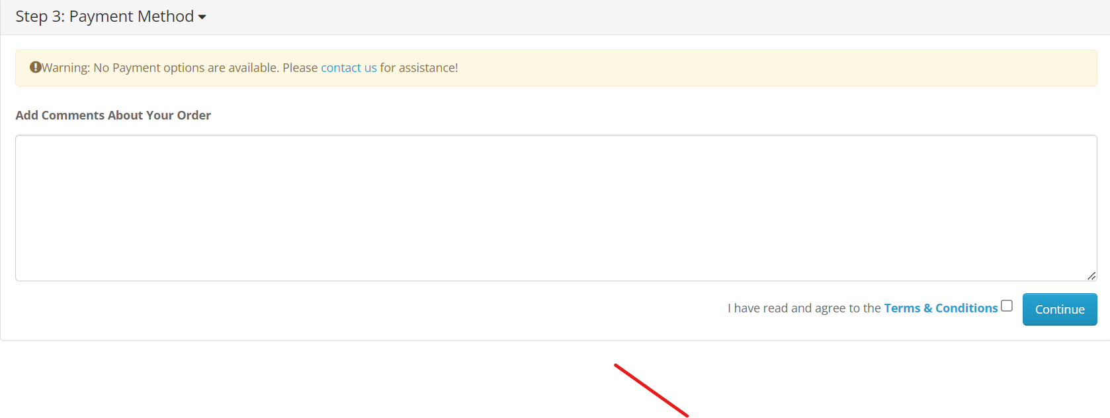

|  |  |
| --- | --- |
| Bug-ID | TU1-I5 |

|  |  |
| --- | --- |
| Brief Summary | To verify by enter Symbols in incode field. |

|  |  |
| --- | --- |
| Severity | Major |

|  |  |
| --- | --- |
| Steps to Reproduce |  |

Steps for Reproducible bugs.

1.Add an item in

shopping cart.

2.Enter all Mandatory fields.

3.Enter Symbols in

pin code field.

4.Click Continue.

**Expected Result**

User should not

be able to continue.

**Actual Result**

User is able to move forward

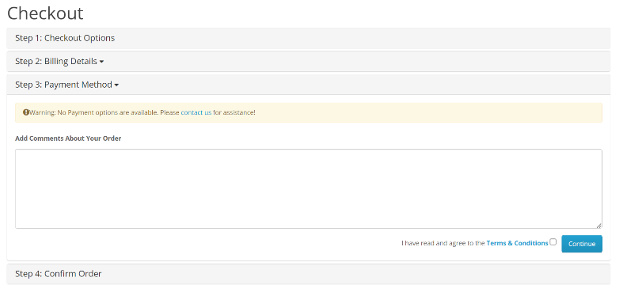

|  |  |
| --- | --- |
| Bug-ID | TU1-I4 |

|  |  |
| --- | --- |
| Brief Summary | User is able to register account by giving weak password |

|  |  |
| --- | --- |
| Severity | Critical |

|  |  |
| --- | --- |
| Steps to Reproduce |  |

Steps for reproducible bug

Steps to reproduce the bug,

1.Open the URL

2.Navigate to "My Account" option in the home page.

3.Click in "Register" option.

4.Enter details in all the mandatory fields (First Name, Last Name,….).

5.Entering weak password or repetitive password in password field.

6.Check the privacy policy.

7.Click on register.

8.Click on continue.

**Expected Result**

User should be able to proceed with a payment.

**Actual Result**

User should not get registered to account.



|  |  |
| --- | --- |
| Bug-ID | TU1-I3 |

|  |  |
| --- | --- |
| Brief Summary | To verify register account functionality by entering numbers in First name and last name field. |

|  |  |
| --- | --- |
| Severity | Major |

|  |  |
| --- | --- |
| Steps to Reproduce |  |

Steps for reproducible defect.

1.Open the URL

2.Click on MyAccount (Drop down)

3.Click on Register

4.User will navigate to Register Account page

5.Enter any numbers in First name and last name field.

6.Check Privacy Policy

7.Click continue.

**Expected Result**

User should not

be able to continue.

**Actual Result**

User can move forward.



|  |  |
| --- | --- |
| Bug-ID | TU1-I1 |

|  |  |
| --- | --- |
| Brief Summary | To Verify Register Account Functionality By Entering invalid format in Telephone field. |

|  |  |
| --- | --- |
| Severity | Major |

|  |  |
| --- | --- |
| Steps to Reproduce |  |

1.open the URL

2.Navigate to "My Account" option on Home Page

3.Click on "Register" option

4.Enter Details in all mandatory fields

5.Enter invalid format in the telephone field

6.Check on Privacy Policy

7.Click on Register

**Expected Result**

User should not

be able to continue.

**Actual Result**

User can move forward.

|  |  |
| --- | --- |
| Bug-ID | TU1-I1 |

|  |  |
| --- | --- |
| Brief Summary | Facing Defect in "Thank you for Registering" mail is not received by the user |

|  |  |
| --- | --- |
| Severity | Major |

|  |  |
| --- | --- |
| Steps to Reproduce |  |

Steps for Reproducable defect

1.open the URL

2.Navigate to "My Account" option on Home Page

3.Click on "Register" option

4.Enter Details in all mandatory fields

5.Check on Privacy Policy

6.Click on Register

**Expected Result**

User should get “Thank you for registering” mail.

**Actual Result**

User did not got any mail regarding registering of account

